**COMSATS University Islamabad, Lahore Campus**

**Mid Term Examination – Spring 2022**

|  |  |  |  |  |  |  |  |  |  |
| --- | --- | --- | --- | --- | --- | --- | --- | --- | --- |
| Course Title: | Object Oriented Programing | | | | Course Code: | | CSC241 | Credit Hours: | 4(3,1) |
| Course Instructor/s: | Dr. M. Aksam Iftikhar | | | | Programme Name: | | BCS | | |
| Semester: | 3rd | Batch: | SP21 | Section: | A | | Date: |  | |
| **Time Allowed:** | **90 Minutes** | | | | **Maximum Marks:** | | | **25** | |
| Student’s Name: |  | | | | Reg. No. |  | | | |

**Question : (CLO-4) Apply OOP concepts using Java to write the code for the following Case Study [10+15**]

* Write an abstract class GeometricObject that declares abstract methods: getParameter() and getArea(), as specified in the class diagram.
* Write the implementation of class Circle, with a protected variable radius, which inherits the GeometricObject class.
* The class ResizableCircle is defined as a subclass of the class Circle, as shown in class diagram. The method resize() modifies the dimension (such as radius) by the given percentage.

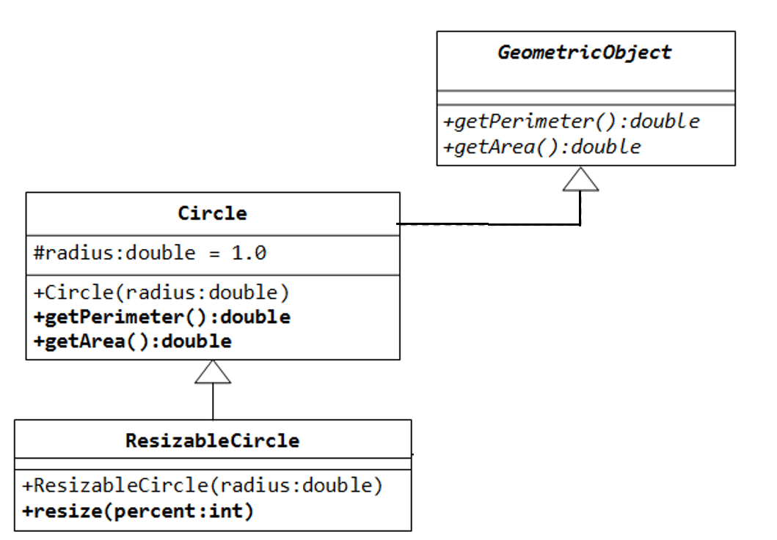

* Write a test program called TestCircle to test the methods defined in Circle.
  1. The program should create an arraylist of GeometricObject and save 3 objects of Circle and 2 objects of ResizableCircle in this arraylist.
  2. Traverse the above arraylist using a conventional for loop. Print the area and perimeter of all the elements inside the array.
  3. Create two empty arrays of Circle and ResizableCircle, respectively (say 5 elements each). Now, again traverse the above arraylist using enhanced for loop, but this time save objects in appropriate array according to the type of the objects (Hint: use downcasting).
  4. *[optional]*: Compare each corresponding circle objects of the 2 arrays created above. Display Circle area only for that pair of circle objects, which have equal radius. Note that as 2 arrays have different length, you should compare only until the length of the shorter array.